
COMMERICAL FOR SALE

Located just a short distance from Fraserburgh’s bustling town centre, this versatile commercial space benefits from excellent visibility, strong passing trade, and convenient nearby parking. Suitable for a wide range of businesses—whether beauty, food, clothing, gifts, or other retail ventures—the premises offer a flexible layout that can be adapted to meet your needs. An ideal opportunity for any business looking to establish itself in a busy, well-connected area.

73 HIGH STREET
FRASERBURGH, AB43 9ET
****£5,000 Under HRV****
Offers over £35,000

✔️PRIME LOCATION
✔️NEAR TOWN CENTRE
✔️PARKING NEARBY
✔️ 2 ROOMS
✔️TOILET AND SINK
✔️ ELECTRIC PANEL HEATING
✔️ DOUBLE-GLAZING
✔️EPC RATING F
✔️ NO BUSINESS RATES

About The
Property
Property
Features

Accommodation Key Features

Prime Commercial Premises Near Fraserburgh Town Centre

Accommodation Key Features

Spacious Commercial property:

The property features a welcoming shopfront, a secondary retail or storage area, a compact kitchen space, and a W.C. It also includes a wet-walled room, making it ideal for use as a beauty treatment area, such as a spray-tan room.

Close to All Amenities:

Boasting a prime position close to the town centre, bustling eateries and ample parking, this premises benefits from exceptional footfall—an ideal setting for a successful, high-performing business.”

Nearby parking:

While the premises don’t offer private parking, there is ample on-street parking and multiple local car parks are available nearby.

Easy Access for Travel:
Accessible transport—whether by bus, taxi, or private vehicle—helps ensure smooth and convenient travel for residents of Fraserburgh as well as those from nearby villages or further afield.”

Don’t let this opportunity pass you by. Reach out to arrange a viewing and see for yourself what modern, effortless commercial living can look like.

Floor plan

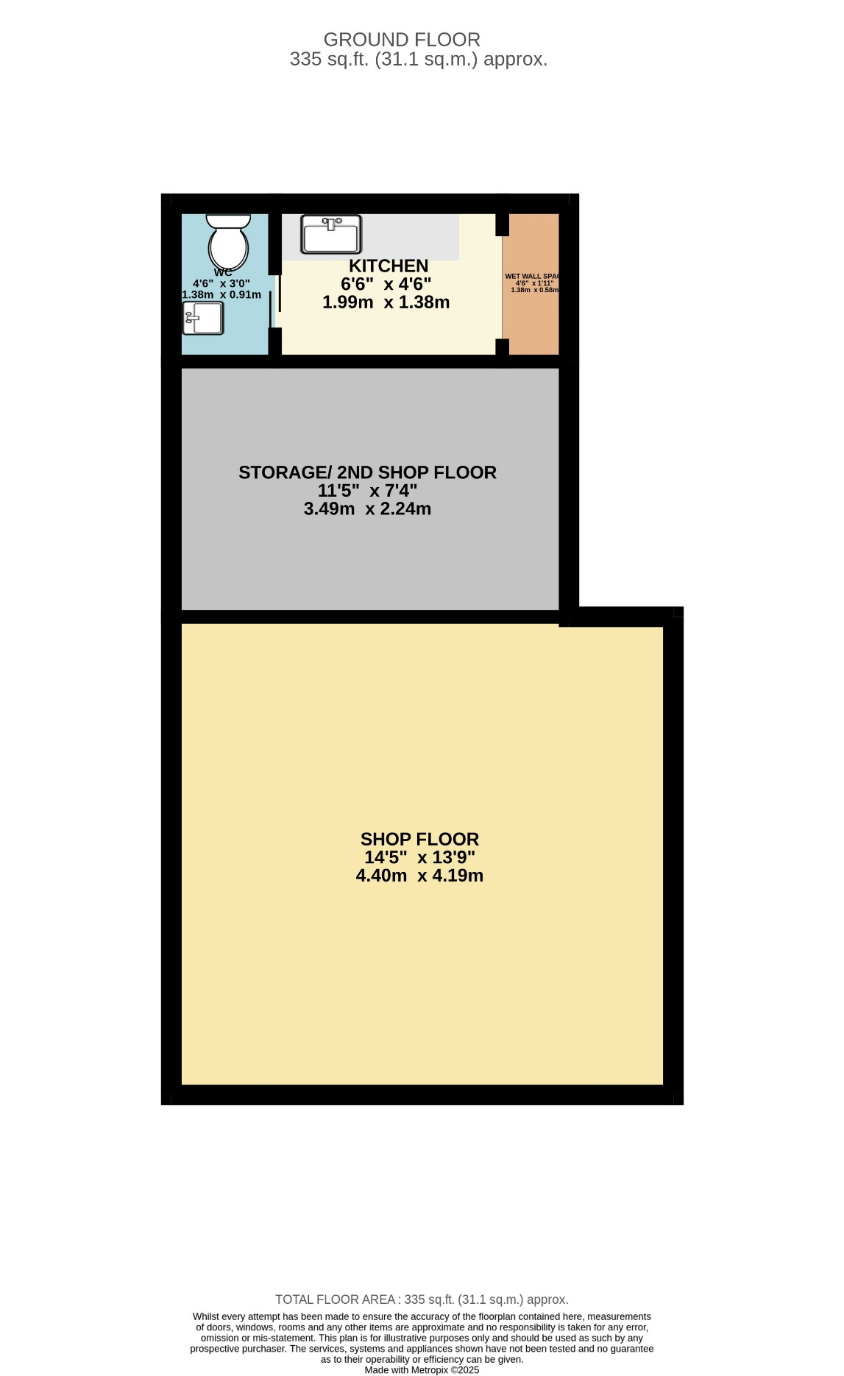

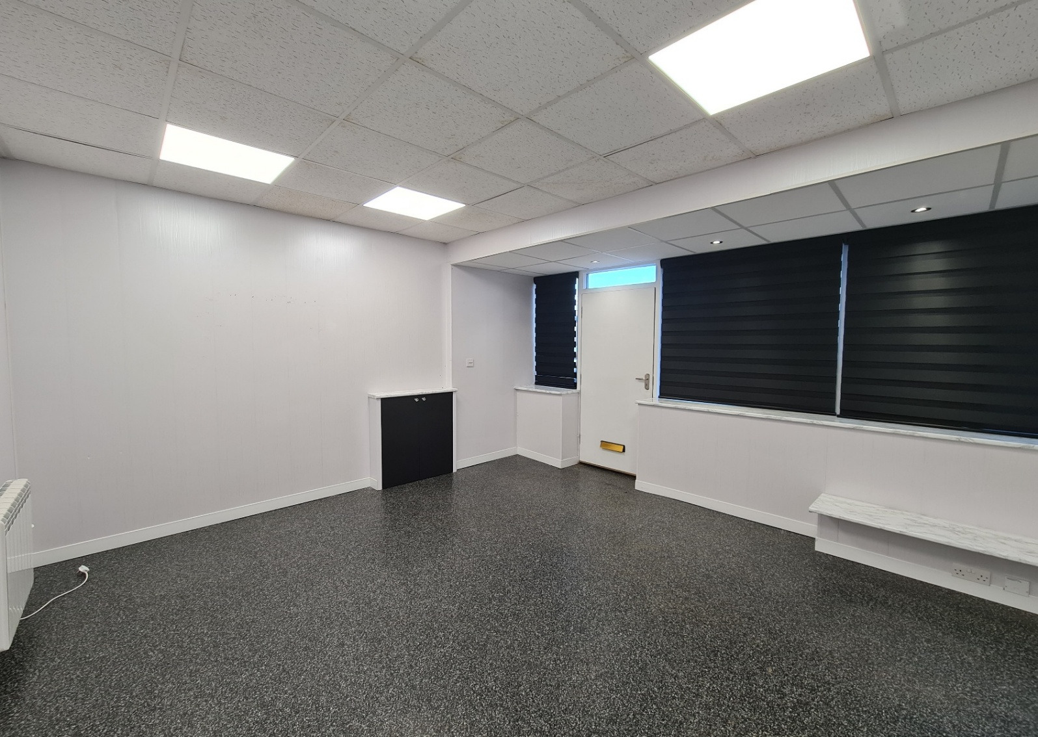
Front of Shop
(4.40m x 4.19m)

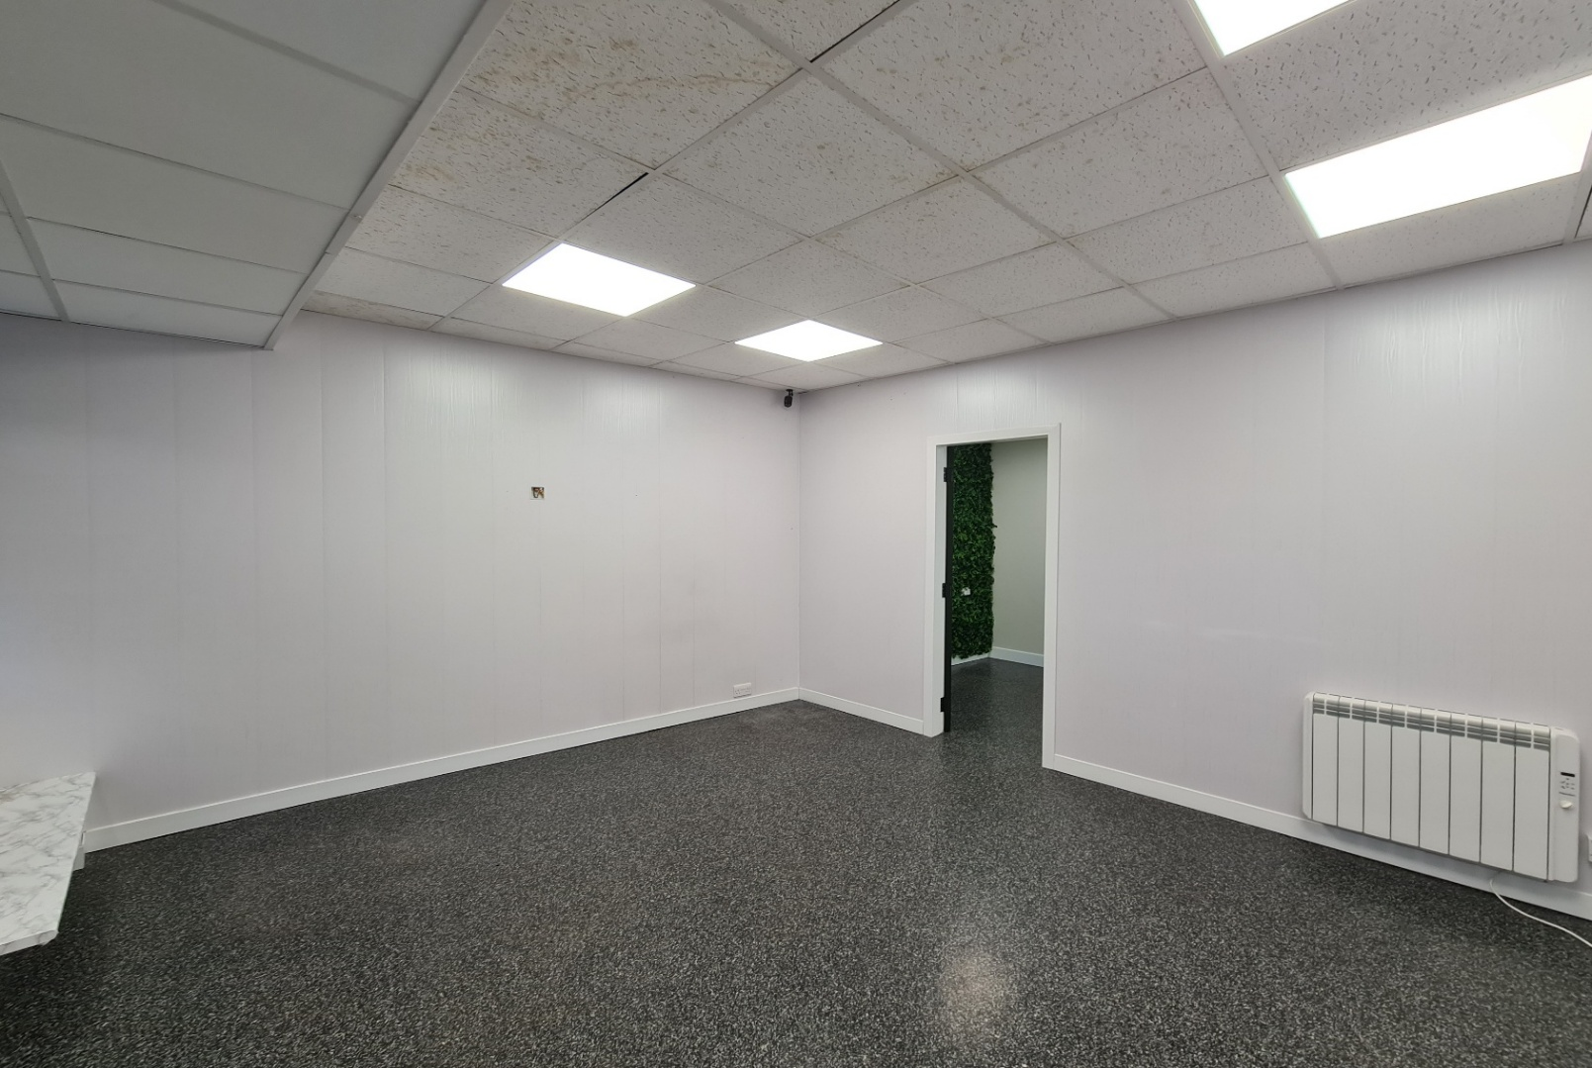
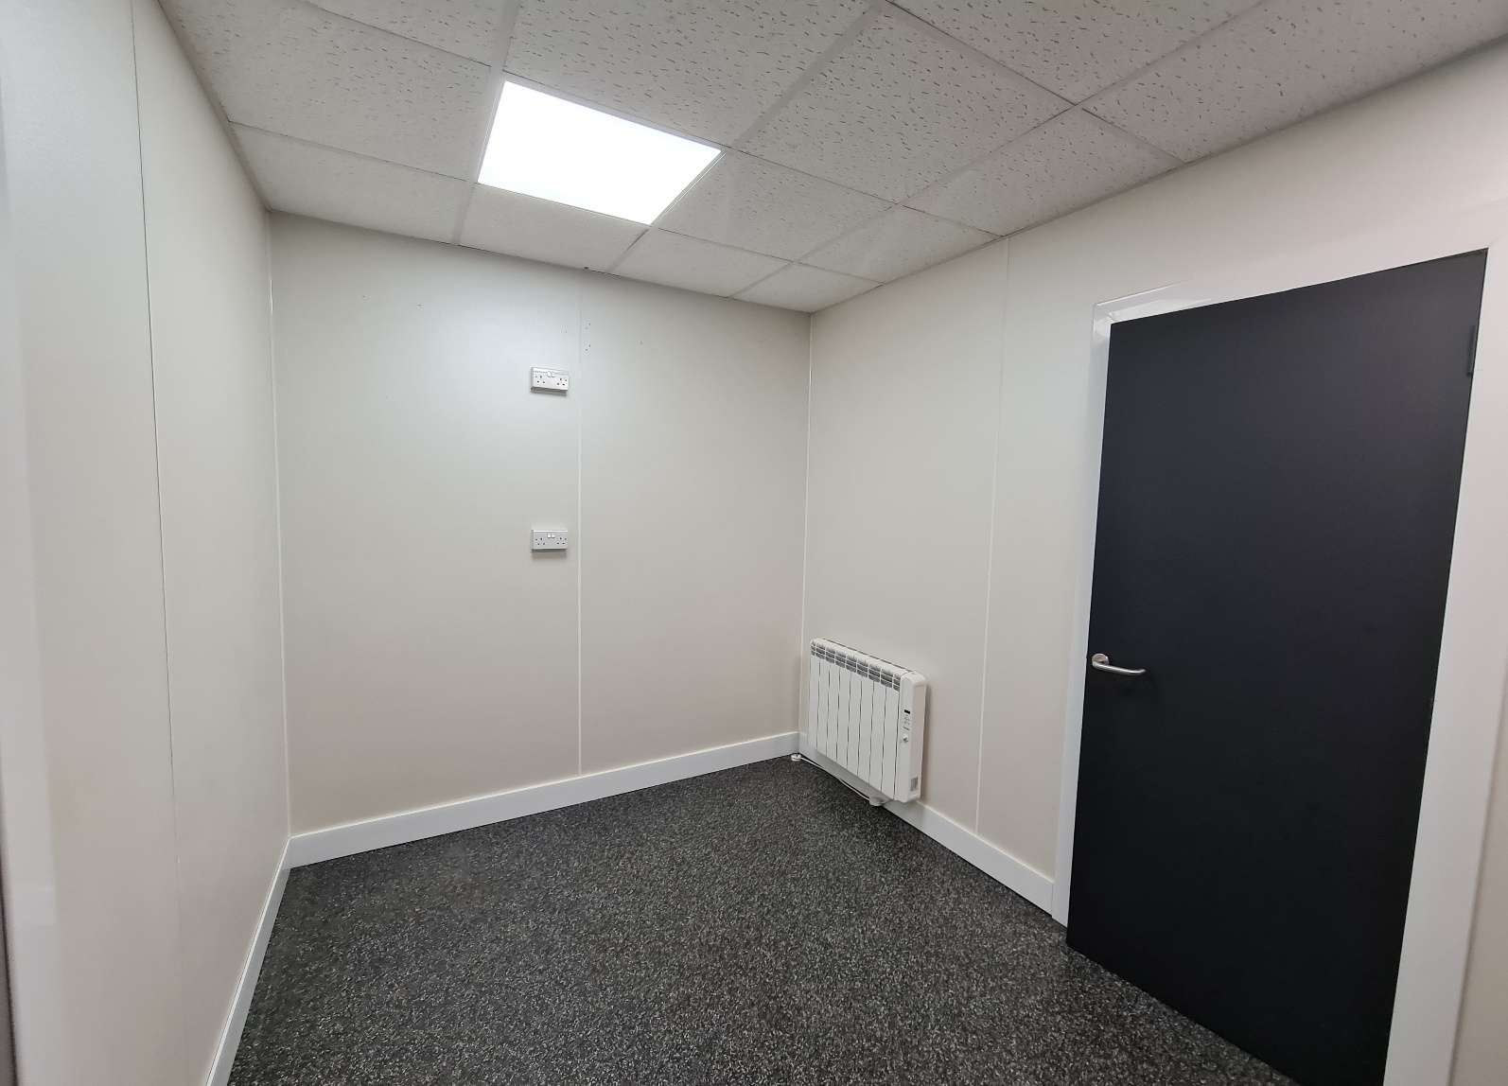
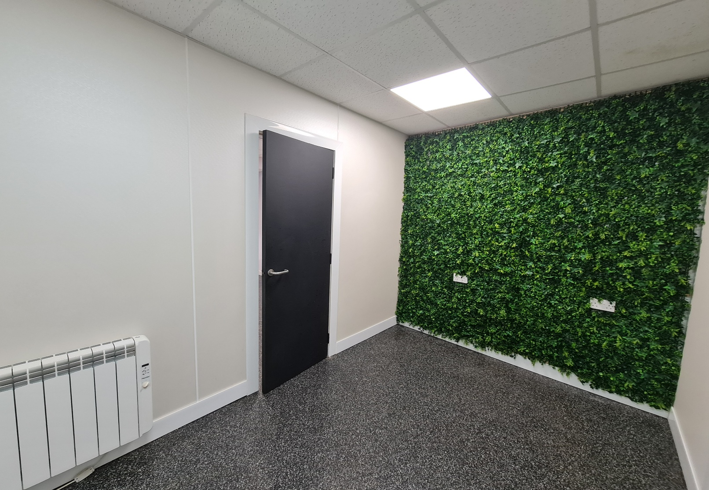
Storage Room/ 2nd shop floor
(3.49m x 2.24m)
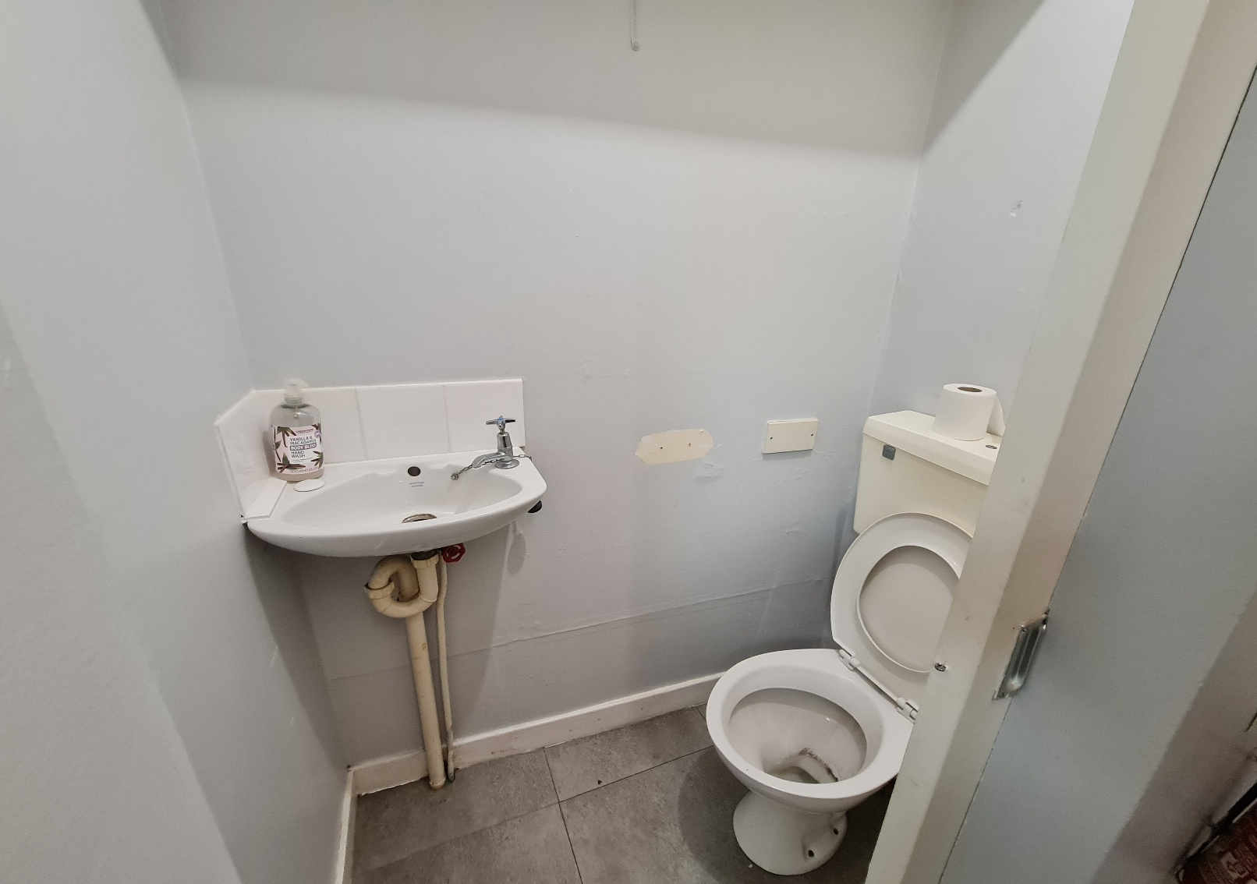
Toilet
(1.38m x 0.91m)

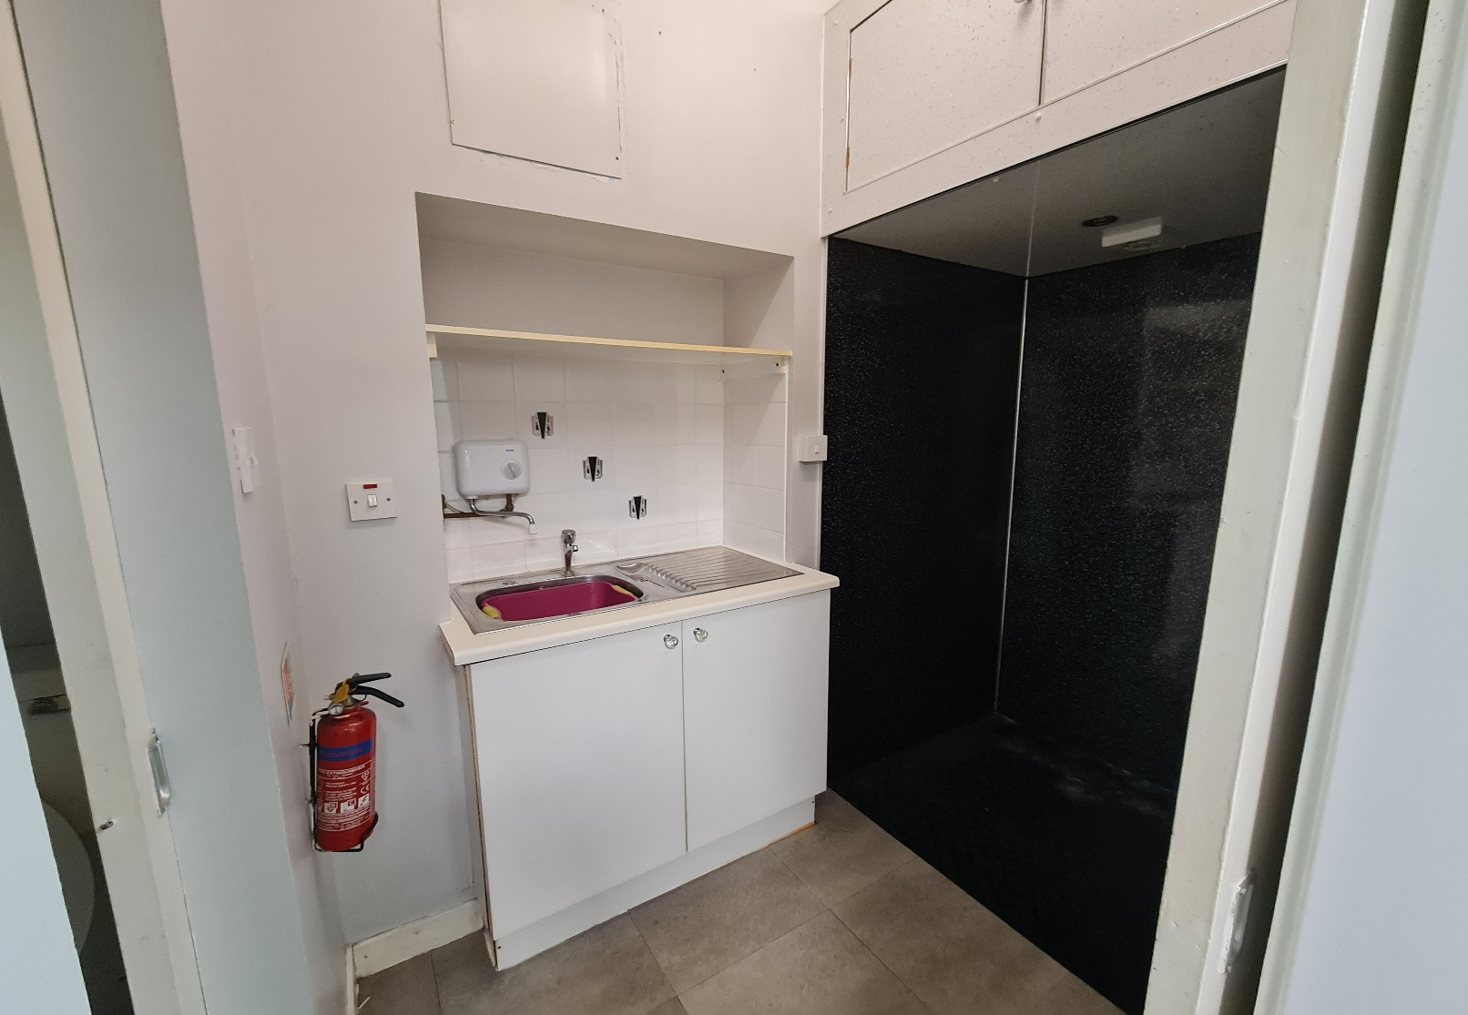
Kitchen
(1.99m x 1.38m)

Mortgages
Mortgages available.
Advice freely given.
Please contact us to arrange a suitable appointment.
Appointments out with office hours are available.
Please Note: Whilst the foregoing particulars are believed to be correct, they are not guaranteed therefore purchasers should satisfy themselves on all points prior to submitting an offer.

N.B Your home is at risk if you do not keep up repayments on a mortgage or other loan secured on it.

You can find all of our properties at www.forbesproperty.co.uk

Offers
Please submit all offers in writing to 68 Broad Street, Fraserburgh, AB43 9AS.

Sale includes

All flooring, blinds. Built-in appliances

Viewings
Please contact our property
centre on (01346) 517124 to arrange a suitable appointment.

